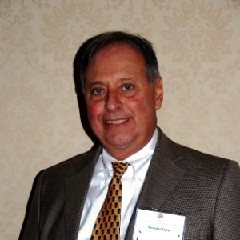
Nicholas C. Forte
Chairman
Erwinna, PA
Nick has lived in Erwinna with his wife, Sharon, for nearly three decades. Since 1986, he has served as a Tinicum Township supervisor which continues to give him a local government perspective. During his tenure, Nick has worked hard to preserve Tinicum Township's natural beauty and rural charm. Additionally, he is a member of the Tinicum Land Conservancy, the Bucks County Open Space Task Force, and the Advisory Committee for the Pennsylvania Canal.
In 2002, Nick retired from Council Rock School District where he taught elementary school for 30 years. He holds a Master's Degree in Education from Arcadia University, a Bachelor of Science in Education from East Carolina University, which is located in Greenville, NC, and an advanced administrative certificate from Temple University. Nick and Sharon have three children and one grandchild. Sharon is also a teacher and currently teaches special education students.
Nick has a steadfast appreciation for the historical character of the Delaware and Lehigh Corridor and is honored to be a part of a group committed to conversation of such an important aspect of Pennsylvania.

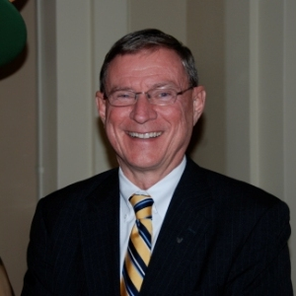
Donald Sachs
Vice Chairman
Hellertown, PA
Donald has served on the board of the D&L and National Canal Museum for a combined 12 years, and he currently serves on the Executive Committee, Finance Committee, and Marketing Committee. Donald worked for 33 years in financial services providing quality marketing for branch operations and banking products. He is passionate about the blending of great recreational opportunities along the D&L trail along with the area’s local heritage as a birthplace of the American industrial revolution makes the Delaware & Lehigh National Heritage Corridor an important resource to preserve, interpret, and enjoy. He enjoys biking, hiking, and walking the D&L trail. Donald says, “I first started enjoying the trail years ago when my wife and I would take our young daughters for walks on the Hugh Moore Park trails, play at the playground, and pick wild raspberries in summer. The walking turned to long distance biking, and now back to walking.”

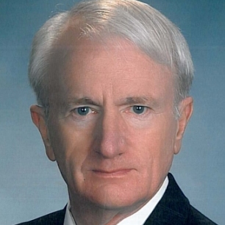
James Birdsall
Secretary
Bethlehem, PA
Jim has served on the Board of Directors of the D&L and National Canal Museum for four years, and is a member of both the Executive committee and the Trail and Facilities committee. He has been a civil engineer for over 45 years, which provides him an avenue to public service through the design and construction of public works. The use of the towpath and trails for recreation and the desire to preserve canal history motivate Jim to serve on the Board, and his main goals as a board member are to help fund maintenance and improvements on the trail, canal, and towpath. Jim received a BSCE and an MBA from Lehigh University, and in his free time, he enjoys spending time with his family and biking and walking along the D&L Trail.

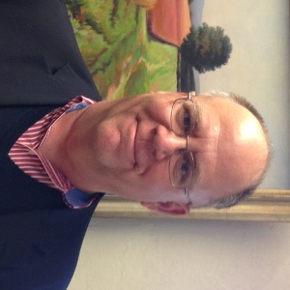
Peter Marmaras

Treasurer

Plainfield, PA

Peter is a Certified Financial Planner as well as a Chartered Financial Consultant. He is a co-founder of Marmaras & Smith, LLC, which provides financial planning consultation and investment advice. Peter is also a registered representative of Cetera Advisor Networks, a broker-dealer member of FINRA, SIPC, and an Investment Advisory Representative of PFG Financial Advisors, Inc.

Outside of his professional life, Peter remains involved in the community in other ways. He leads the Finance Team at Wesley United Methodist Church in Bethlehem, and once co-hosted a weekly radio show. In his free time, Peter enjoys reading and writing poetry, being in the outdoors, and especially fly fishing. He lives in Plainfield Township, Pennsylvania with his wife and three children.

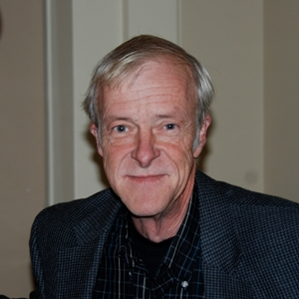
Michael Burnside
Wilkes-Barre, PA
Mike Burnside is a native of Northeast Pennsylvania and a graduate of Wyoming Seminary and Kings College (Business Administration) in Wilkes-Barre. He received an MBA from the Wharton School at the University of Pennsylvania and an MA in Creative Writing at Wilkes University. He has worked at Fowler, Dick & Walker in Wilkes-Barre, John Wanamaker in Philadelphia, Commonwealth Telephone, WVIA Public Broadcasting, Etruscan Press, and the Cultural Council of Luzerne County. Mike is currently a photographer. Through his photography, he attempts to find the images that people may often see at a glance but never truly notice. His photography tends to be abstract work grounded in nature. He is a Director of the Cultural Council of Luzerne County, the Pennsylvania Humanities Council, the Riverfront Parks Commission and several other organizations and lives at Harveys Lake, Pennsylvania.http://burnsidephotographic.com/wordpress/

James P. Creedon
Bethlehem, PA
Jim Creedon is Senior Vice President for Construction, Facilities and Operations at Temple University. As a cabinet member of Pennsylvania Governor Edward Rendell he served as Secretary of the Department of General Services (DGS) from 2005 to 2010, Creedon managed one of the largest operating departments of Pennsylvania state government. DGS managed over $4 billion in construction, annually managed over $4 billion in procurement and had over 1,000 employees. In 2009, Creedon was also appointed by Governor Rendell as Pennsylvania’s Chief Implementation Officer for the American Recovery and Reinvestment Act (ARRA). In that role, he managed the development, selection, delivery and monitoring of over $14 billion in spending.
Creedon resides in Lower Saucon Township, Northampton County, with his wife Jan, who serves as Director of Human Services for Lehigh County. He has two sons, Matt, a student at the University of Massachusetts and Stephen, a student at Allentown Central Catholic High School, and a daughter, Erin, who works for PBS TV-39 in Bethlehem.
He is also an adjunct faculty member at Temple University where he teaches graduate courses in Project Management, Continuity of Operations and Public Budgeting and Finance. He is also President of the Friends of the Levitt Pavilion at Steel Stacks.

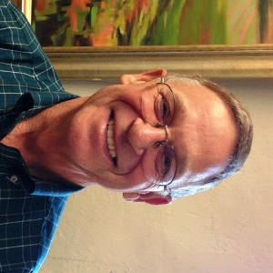
Darrell Crook

Nazareth, PA

Darrell brings nearly a lifetime’s worth of community engagement experience to the Board of Directors. A retired educator, he currently serves on the Nazareth Area School Board. He is also a member of the Nazareth Moravian church, Nazareth Area Food Bank, Moravian Historical Society, PA Association of School Retirees, Odyssey of the Mind, and the Nazareth Area Lions Club.

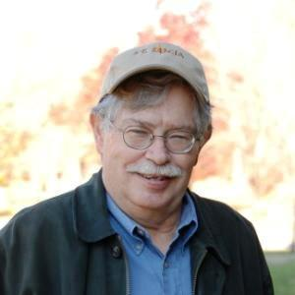
Charles Derr
Freemansburg, PA
Charlie is a life-long resident of Freemansburg where he was born, grew up, and still resides in his grandparents’ house. He is married with three successful children, who all grew up with the Lehigh Canal in their backyard. This proximity to the canal has influenced several facets of Charles’ life.
Retired from Hugh Moore Park, Derr was the maintenance manager for 25 years. He was also a commission member when the Delaware & Lehigh National Heritage Corridor was founded in 1988. Since that time he has served on the board for the majority of its existence. Charlie is also an active volunteer for the D&L.
His passion for canals has led him to hold several other positions related to the preservation and conservation of canals. Charlie is a former officer of the Pennsylvania Canal Society as well as a member of the American Canal Society since 1972, where he has held the positions of secretary and treasurer. He was also a founder and officer in the Freemansburg Canal Society. Derr also serves his community by sitting on the Freemansburg Borough Council for a total of 38 years, including terms as the Council’s president.

Marla Mensch Doddo
Scranton, PA
Marla Mensch Doddo is currently the Youth Services Manager for the Luzerne Schuylkill Workforce Investment Board (LSWIB). Doddo has been in this position since 2010. In this position she manages and directs providers for WIA Title 1 Youth service programs in a two county area and manages an all-volunteer Youth Council for LSWIB. Doddo also serves as an interim PA CareerLink® Site Administrator for the LSWIB and represents the LSWIB on various workforce and educational advisory councils. Doddo’s expertise in grant writing has secured over $2 million in grant awards both in the workplace and with volunteer organizations.
Doddo’s community service volunteer experiences are diverse. Currently serving on the Board of Directors of the White Haven Area Community Library, she is chair of the building fund committee, chair of the nominating committee, and was president from 2010-2012.
A native of Danville, Doddo currently lives with her husband in Dennison Township and is the mother of three adult children. Her hobbies include walking, biking, gardening, reading, entertaining and improving her community.

Michael Drabenstott
Allentown, PA
Michael Drabenstott has nearly 25 years’ experience in a diverse range of public relations and marketing disciplines including media relations, community relations, crisis communications, interactive promotion and advertising. He is one of three founders of Spark, a Bethlehem-based marketing communications agency that serves clients including Martin Guitar, PPL EnergyPlus, B. Braun and Discover Lehigh Valley.
His community and professional associations include Leadership Lehigh Valley Board of Directors (President); Renew Lehigh Valley (current and founding board member); the West End Alliance (President), a neighborhood development not-for-profit focused on Allentown’s West End Theatre District; the Board of Associates at Muhlenberg College and Cedar Crest College, and the St. Luke’s Half Marathon Organizing Committee. Past board affiliations have included Allentown Symphony Association (vice president) and International Association of Business Communicators/Lehigh Valley Chapter (past president). He also sits on the City of Allentown’s “Connecting our Communities” committee overseeing the planning and build-out of the city’s trail network and bicycling facilities. He is a graduate of Bowling Green State University with a B.A. in Journalism. He is also a 2001 graduate of the Leadership Lehigh Valley program and was named LLV alumnus of the year in 2009.
Drabenstott is an avid runner, biker and lover of the outdoors, and has logged hundreds of miles on the D&L Trail from Easton to Lehighton. A 20-year resident of the city of Allentown, he is married with two children.

Bill Getchel

Point Pleasant, PA

Bill is a Long Term Care Specialist, helping to provide clients with the peace of mind that comes along with long-term insurance. He has been repeatedly recognized for the contributions to his community and dedication to his clients. On the D&L Board, Bill works to preserve the history of the Delaware and Lehigh Canals and maintain the trails for the community. In his free time, Bill enjoys fishing and gardening. He has two daughters and four grandchildren, and lives in Point Pleasant with his wife, Sally.

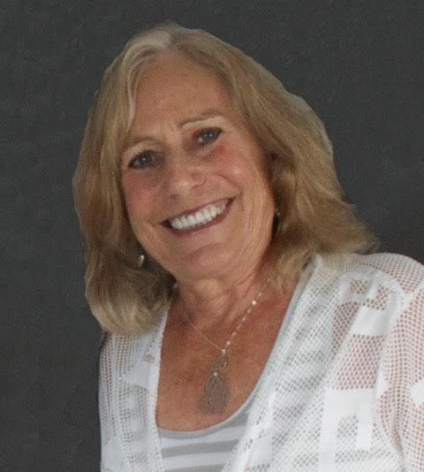
Sharyn Keiser
New Hope, PA
Sharyn has dedicated two years of service to the D&L. As a member of the advancement committee, she adds elements of leadership, collaboration, organizational development to the Board. Sharyn enjoys continuing to give back to the community through public service to an organization that provides historical, educational, recreational, and economic development to the eastern region of the state, offering enrichment opportunities to a multitude of people. Recruitment, funding, membership, and sponsorship are Sharyn’s areas of interest and focus at the D&L. Her first passion is her family and friends, and she also has a love for her community and the wealth of opportunities it affords her. Recreational activities, biking, walking, kayaking, and boating are a big part of her life. She was very passionate about her 32 year career as a principal in public education, as well as the 9 years she spent as a training manager in pharmaceutical research and development. Her public service to the community has over a 20 year history…New Hope Borough Council for 14 years (as president and vice president), member of the Planning Commission, Chairperson of the Revitalization Commission, and a member of Landmark Towns. Sharyn has received awards from the Pennsylvania Department of Education, the School District of Philadelphia, the Pennsylvania Borough Association, New Hope Borough, and the New Hope Chamber of Commerce, as well as a Pharmaceutical Encore Award.

John (Jack) R. Krissinger

Macungie, PA

Jack has served on the Board of Directors since 2004. An active member of the community, he is the President of Lehigh Fuels, Inc., and also serves on the Board of Directors of Miller-Keystone Blood Center. Helping to preserve the history of the Delaware and Lehigh Canals is one of the most important services Jack sees the D&L provide to the community, and is the reason he continues to give his time and skills to the Board. In his free time, he enjoys spending time in the outdoors, and especially skiing, camping, and playing softball.

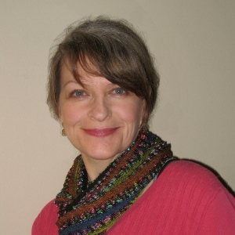
Julia Maserjian
Bethlehem, PA
Julia Maserjian is a project specialist at Lehigh University’s Digital Scholarship Center. She has worked in public history and digital project management for over a decade, and has shepherded the development and launch of projects to include the Bethlehem Digital History Project and Beyond Steel: An Archive of Lehigh Valley Industry and Culture. Her community service includes work with the City of Bethlehem on preservation planning and historic interpretation.

John P. Miller

Bethlehem, PA

As a member of the Pennsylvania Canal Society, John has done extensive research on the Lehigh Canal, and written a short history of the canal for educational groups. He is one of the founding members of the National Canal Museum on its original site, and was instrumental in bringing our historical collection of canal memorabilia, photographs, and records to the National Canal Museum for display and safe keeping. He also volunteered as a guide at the original Canal Museum, and as a boatman and mule driver on the Josiah White II. In his free time, John and his wife, Jaquie, enjoy spending time at their farm in Bethlehem, PA.

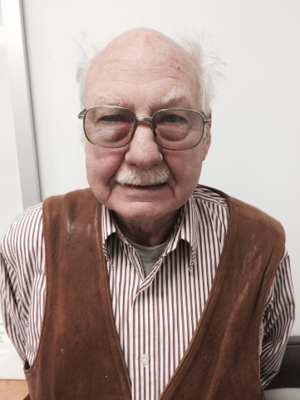
Vance Packard

Thornhurst, PA

Vance made a career as an industrial archeologist for the Pennsylvania Historical and Museum Commission (PHMC) for over thirty years. His researched initially focused on prehistoric American Indian settlements, and later on colonial American settlements. He led archaeological excavations at Valley Forge, Washington Crossing, and Curtin Village, and an iron planation near Bellefonte. He is the founder of the Society for Industrial Archaeology, and served as the Director of the Drake Well Museum as well as the Pennsylvania Historical and Museum Commission’s Western Region. All of the PHMC’s industrial sites were overseen by Vance beginning in 1989, signaling a period of restoration and expansion at those sites.

Sean Robbins

Shavertown, PA

Sean Robbins is a 1993 cum laude graduate of Villanova University, where he majored in political science and minored in history. He went on receive his law degree from the Dickinson School of Law at Penn State University in 1997. As an attorney with the Commonwealth of Pennsylvania, Department of Environmental Protection in the Northeast Regional Office, Sean counsels different Department programs on a variety of issues that arise in the eleven county region covered by the office. Sean is currently a board member with the Luzerne County Transit Authority, the Wilkes-Barre YMCA, Wilkes-Barre Racing and the Anthracite Scenic Trails Association (ASTA). He enjoys spending most of his free time outdoors skiing, hiking, running or biking, and has been an avid triathlete since 1994. Sean has earned USA Triathlon All American honors for a number of consecutive years and has competed in events across the county, including the Ironman Triathlon World Championships in Kailua-Kona, Hawaii on five occasions. He enjoys spending downtime and walking his two dogs, Hulk and Gibbs.

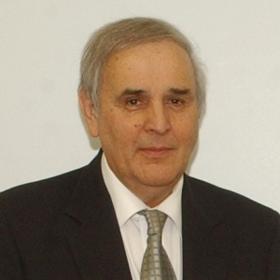
Robert Skulsky
Hazleton, PA
Robert is a life time resident of the area and has been married to his wife, Leona, for 46 years. He is a father to Lee Ann, Robert, and Linda Skulsky, as well as a grandfather of six. Robert worked at the Department of Defense for 37 years, the Electronics Commerce Resource Center at the University of Scranton, and is presently the Executive Director of the Greater Hazleton Area Civic Partnership.
Robert is an avid outdoorsman with a special passion for hunting, fishing, wildlife, camping, and environmental preservation. These interests have led Robert to partner with the Greater Hazleton Rails to Trails (GHRT) in order to maintain trails, develop an education program on local wildlife, and promote economic development. Robert also works with several wellness organizations to promote healthy outdoor living. He was part of the Keystone Active Zone, helped with groups tying to eliminate acid mine drainage. In October 2011, he was a recipient of the Environmental Partnership Award from Pennsylvania Environmental Council (PEC) for his leadership and commitment to enhance the environment of Northeastern Pennsylvania through his work as the Executive Director of the Greater Hazleton Area Civic Partnership.
Now in semi-retirement, Robert’s first priority is to enjoy the time he spends with his family. However, he does manage to find time to partner with several organizations in order to preserve and maintain the habitats of local wildlife. Robert continues to make connections with others in the community in order to develop more parks, trails, greenways, and outdoor sites for our children and grandchildren to enjoy forever.

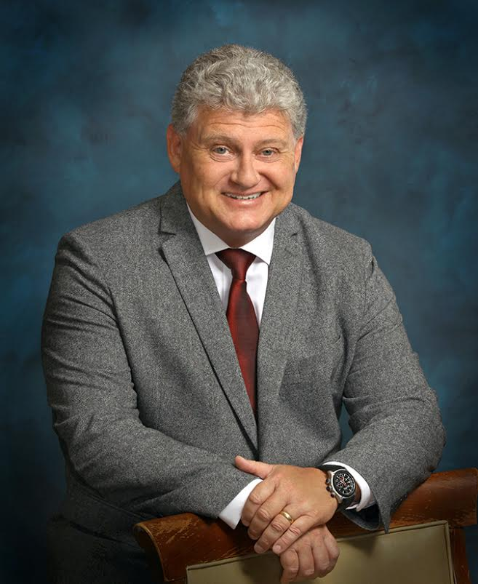
Lon Snowden

Allentown, PA

A native North Carolinian, Lon is a management consultant in the Lehigh Valley of Pennsylvania. He served in the Coast Guard for over 30 years, and currently resides in the Lehigh Valley with his wife.

Lee Zink

Weatherly, PA

Lee is an avid user of the trail, and considers it to be one of our area’s greatest assets. Having grown up in Weatherly, he spent countless hours of his youth roaming the Lehigh Gorge, and has had the pleasure of seeing it through the eyes of his own children and now enjoy introducing my grandchildren to all the gorge has to offer. Realizing how much has been accomplished, recognizing how much more there is to do and believing in the future of this outstanding organization.

